# Table of Contents

**Network-as-a-Service Runbook**

**RAN LLD Report Template**

**Facebook NaaS Runbook**



Table of Contents 1

Document Control 3

About Design Template 4

Document Purpose 4

Executive Summary 4

1. Introduction 5

2. RAN Performance Analysis 5

Coverage Plot 5

Throughput Plot 5

SINR Plot 5

Best Server (Overlapping) Plot 5

3. RAN Configuration and Parametrization Description 5

RAN Configuration Summary 5

Neighbor Strategy 6

Mobility Strategy 6

RAN Features 6

3. Bill of Materials 6

# Document Control

'- Revision Control sheet allows to maintain a record of changes made on the document.

|  |  |  |  |
| --- | --- | --- | --- |
| Version N° | Issue Date | Status | Reasons for Change |
|  |  |  |  |
|  |  |  |  |
|  |  |  |  |
|  |  |  |  |

Table 1. Revision History

# About Design Template

## Document Purpose

The purpose of this document is to outline the Low-Level Design (LLD) Recommendations.

The document is split into following main sections:

* RAN Performance Analysis
* RAN Configuration and Parametrization Description
* Bill of Materials

*Note: The above sections may change depending on the customer’s needs*

# Executive Summary

Brief summary of the LLD Recommendation that management team can examine to rapidly become acquainted with LLD content without the necessity to read the complete document.

# 1. Introduction

Introduction to document, that should contain:

* RAN Configuration Description

*General description of the final configurations obtained from the LLD process.*

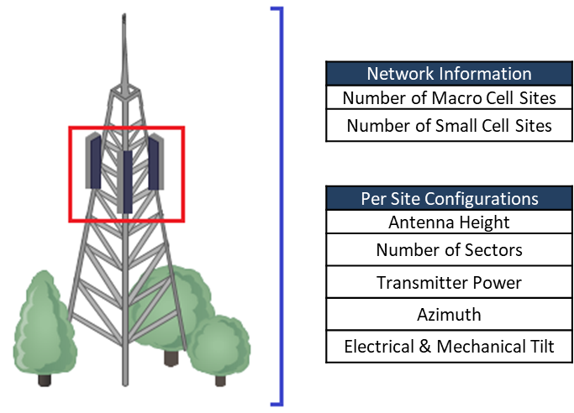

Figure .

* Configuration Refinements Discussion

*Brief discussion of the obtained configurations from the LLD process.*

# 2. RAN Performance Analysis

Analysis of the performance plots, conclusions obtained from them and modifications to the High-Level Design (HLD) results.

### Coverage Plot

*Analysis, images, and discussion of the Coverage Plot.*

### Throughput Plot

*Analysis, images, and discussion of the Throughput Plot.*

### SINR Plot

*Analysis, images, and discussion of the SINR Plot.*

### Best Server (Overlapping) Plot

*Analysis, images, and discussion of the Best Server (Overlapping) Plot.*

# 3. RAN Configuration and Parametrization Description

Summary of the Radio Configuration and parametrization for sites integrating the network.

A summary about the logic followed for the definition of RAN parameters such as local RF parameters (PCI and ERFCN), mobility and neighboring rules.

## RAN Configuration Summary







### Neighbor Strategy

### Mobility Strategy

### RAN Features

# 3. Bill of Materials

Summary of the Resultant Bill of Materials required for the overall network.